Intelligence Request System (ISR) – User Instruction Manual


Kim S. Espat
American Military University
ENGL220 I001 – Technical Writing
Professor Yezbick, Rosalie
1 December 2025

Table of Contents

- Introduction 3
- Product Overview 3
- System Requirements 3
- Safety & Security 4
- System Components 4
- Step-by-Step Instructions 5
  - Account Creation 5
  - Intelligence Request submission 5
  - Request tracking via Dashboard 6
  - Receiving Intelligence Products 6
7. FAQs & Troubleshooting 7
8. Contact & Support Information 7
9. Part II: Instruction-Writing Process 9

Introduction
Thank you for considering Athena Analytics as your information and intelligence provider. The Intelligence Request System (IRS) is your tool to request, track, and receive intelligence services and products. The system guides users through the step-by-step process of requesting your uniquely tailored products, whether that be an open-source intelligence analysis, an area threat assessment, or a live briefing from one of our experienced intelligence analysts.
This manual will aid you in navigating Athena Analytics’ interactive system in a safe and efficient manner to best provide you with the information and analysis you require while safeguarding your information and privacy.
Product Overview
The IRS provides centralized intelligence workflows. A few key capabilities provided to Athena clients include:
- Intuitive dashboard
- Standardized request forms
- Secure product delivery
- Options for client/analyst product discussion
System Requirements
- Computer or mobile device
- Internet connection
- Web browser (Google Chrome, Microsoft Edge, etc.)
- Organization login credentials
Safety & Security
To maintain your organization’s operational security and prevent unauthorized disclosure of your information, we recommend the following:
- Individuals must not share login credentials.
- Unless your organization has the appropriate authorization, do not upload classified material.
- Properly secure all downloaded intelligence products in accordance with your organization's information security policy.
- The use of a virtual private network (VPN) is highly recommended.
- Comply with all applicable operations security (OPSEC), information security (INFOSEC), and data handling regulations relevant to your respective role.
Accessing the Intelligence Request System (IRS)
- Begin the process by navigating to the Athena Analytics homepage (https://www.athenaanalytics.org/).
- Log into the platform with your unique user ID and password.


- If a profile has not yet been established, one can be requested via the initial service inquiry at the bottom of the home page.
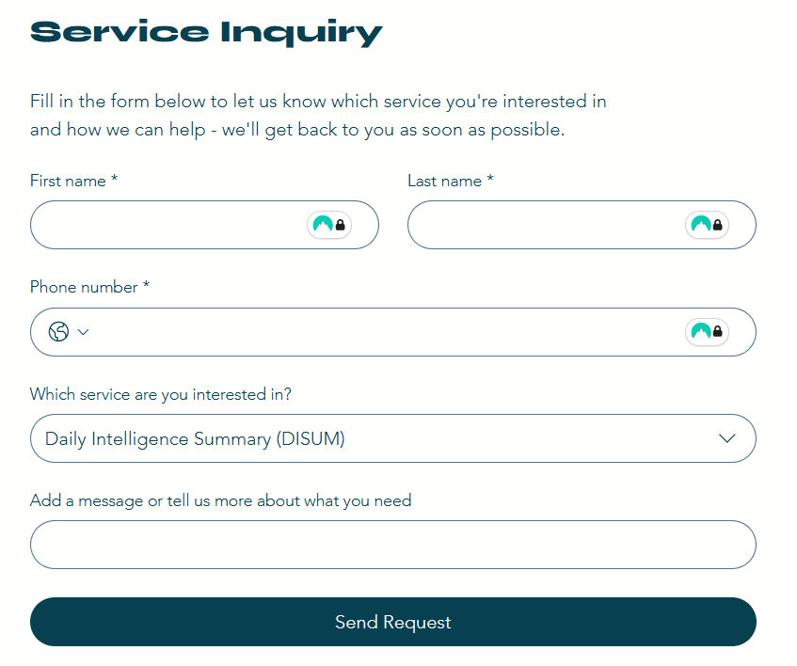
- Shortcuts to dashboard products and services can be found on the corresponding pages. Quick links are located on the navigation bar at the top of the page.
  - Select the Product Type tab for a specific deliverable product.
  - Select the Services tab for a specific services with a variety of product types to add onto each service.

- After the client has been logged in, the selection of any product or service from the corresponding pages will redirect the client to the IRS dashboard.
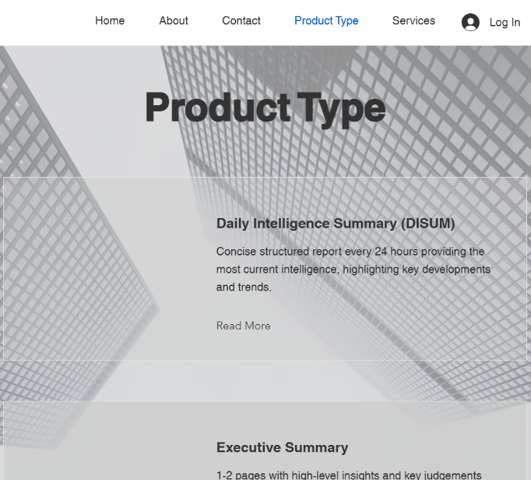
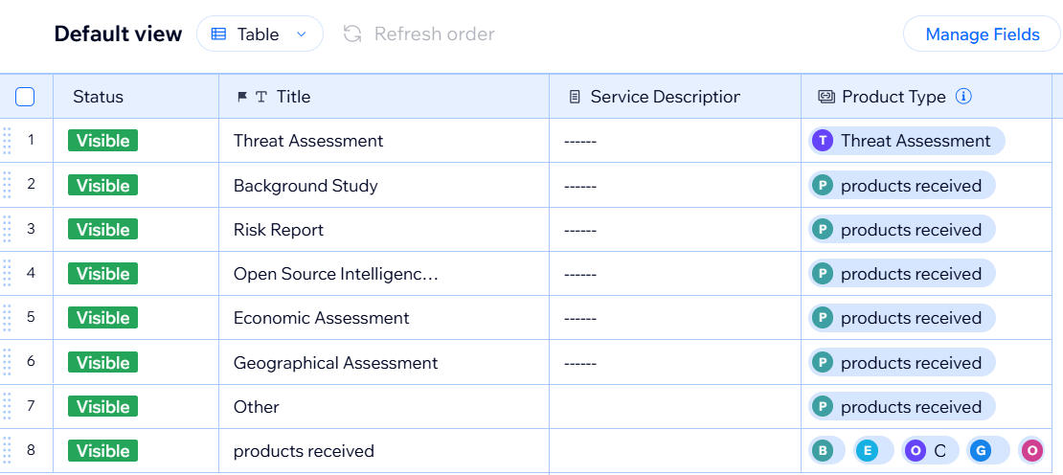
IRS Dashboard

- Submit new requests directly from the dashboard.
  - Select each cell in the dashboard, and either a dropdown menu will appear, or you will be presented with the option to enter text.
  - After the required information has been added, the user can submit the request using the “submit” button at the bottom of the dashboard.
An associate will contact you within the hour or at your earliest convenience (if specified) to tailor your request to your specific needs.
Troubleshooting
If you are experiencing technical difficulties accessing the dashboard or submitting a request, try the following steps:
- Log out and log back in.
- Switch browser
- Close the window and clear cookies, then log back in.
- Check VPN settings
- Restart the computer or mobile device and verify VPN settings before logging in.
If the above steps did not alleviate the problem, please contact Athena Analytics immediately, and our 24-hour technical support staff will assist you.
Contact
Email: support@thenaanalytics.org
Phone: 1-800-000-0000
81-000-000-0000
Physical Address: 1 First Street, Smalltown, UT, US

Part II
Target Audience
The target audience for the IRS is the client base of Athena Analytics and includes individuals from across the public and private sectors seeking information and analytics using open-source intelligence (OSINT). Users are expected to be in the upper-middle class to high income earners and between the ages of 25 and 65, with moderate technological literacy. Clients are expected to come from the fields of corporate security, logistics, finance, emergency management, insurance, and energy. They are expected to have varying degrees of familiarity with intelligence systems.
Layout & Design
The Arial font was chosen for headings, and Times New Roman was chosen for the body. Both text fonts were decided on based on their professionalism and ease of reading. Headings use a different font in bold than the body to make transitions easily identifiable. White space was incorporated strategically to alleviate visual clutter. Color choices were kept to a professional black and white, reflecting the expectations of the industry. Limited images were used to avoid distraction; only those needed for instructional purposes were incorporated within the body of the document.
Challenges
The primary challenge to developing this manual was whether or not to use an impersonal third-person writing style or to directly engage the reader. A neutral third-person style is typical of what is found within this industry, but not all the clients are likely to be familiar or comfortable with this form of engagement; therefore, a more direct second-person style was used. This document is likely to be used either when a client is getting started or is having technical issues. A more direct and personal tone is likely to be more settling than the standard neutral and indifferent tone that will be used in the company’s intelligence products.
Planning Steps
Prior to beginning the document, an outline was put in place to ensure all the required components were included. The intended target audience was identified and analyzed to determine how to best engage with them based on their technical proficiency and likely functions within their organization. Next, the IRS workflow was mapped in a step-by-step sequence, from login to product delivery. Multiple reviews and revisions were conducted to ensure proper grammar and formatting.

